UVM Kickstart Lab - ALU Agent

SystemVerilog + simulation basics

Compile + Run
Vivado XSIM is used to compile and simulate SystemVerilog designs. The XSIM toolchain consists of three commands: xvlog (compile), xelab (elaborate), and xsim (simulate). A successful compile produces no errors in the terminal output.
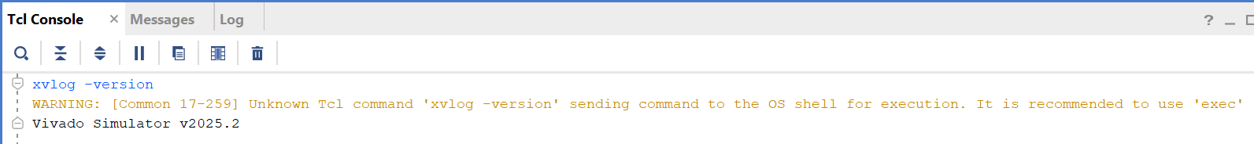
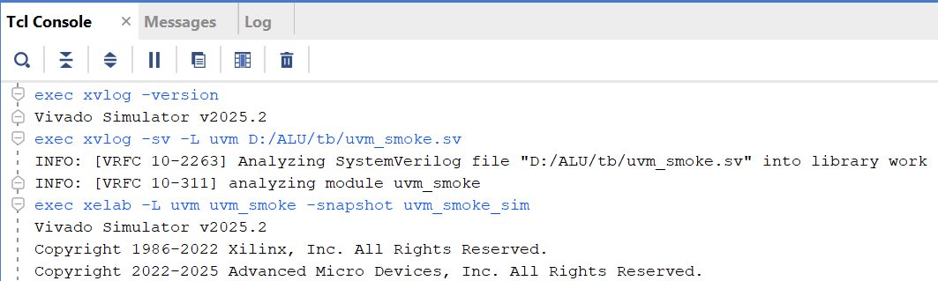

The 0 errors line in the console output means the simulator successfully parsed and compiled the SystemVerilog file. This proves the simulator is correctly installed and able to build SystemVerilog files. The UVM_INFO tag followed by the message text confirms two things: the compile step succeeded (the file was valid) and the run step executed (the initial block ran). This is the difference between compile-time and run-time success.

Clock + Reset Behavior
Digital designs typically use a synchronous clocking scheme.
- The posedge clk is the sampling edge.
- A synchronous reset takes effect on the next rising clock edge.
- The first active cycle occurs immediately after reset deassertion.

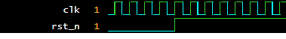
clk toggles continuously; rst_n asserts low and deasserts high. The first active cycle occurs at the first posedge clk after rst_n=1.

Compile Errors
XSIM reports errors with the file name and line number. Always fix the first reported error first — later errors are often caused by the first one.

Waveform Viewing
In Vivado, after simulation open the Wave window. Add signals by dragging from the Scope panel or right-clicking signals. To save waves use a .wcfg file or capture a screenshot for documentation.
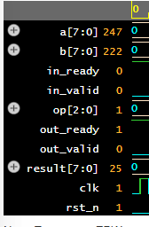
Waveform viewer displaying clk, rst_n, and ALU signals for timing verification.

  - UVM Basics
UVM Component Roles
- sequence_item: Defines the fields of a transaction.
- sequence: Generates a stream of sequence_items.
- driver: Drives DUT pins based on sequence_items.
- monitor: Observes DUT pins and reconstructs transactions.
- scoreboard: Compares DUT outputs with a reference model.

UVM Hierarchy
A standard UVM testbench follows this structure:
uvm_test
env
agent
sequencer
driver
monitor

build_phase creates components
connect_phase connects TLM ports

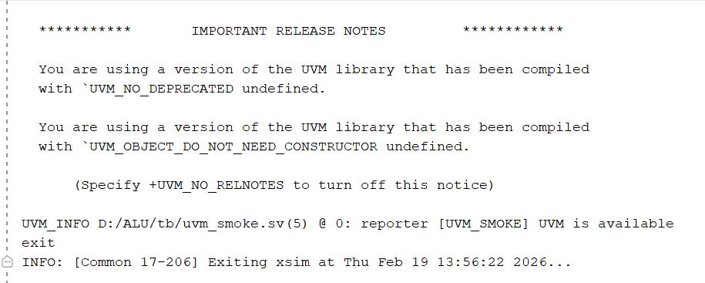
The UVM banner confirms that the UVM library is loaded and running.

Virtual Interface
A virtual interface connects class-based UVM components to SystemVerilog interface signals.
It is set in the top module using:
uvm_config_db#(virtual alu_if)::set(null, "*", "vif", alu_vif);

Selecting Tests and Verbosity
Tests are selected at runtime using:
-testplusarg UVM_TESTNAME=alu_smoke_test
Verbosity is controlled using:
-testplusarg UVM_VERBOSITY=UVM_MEDIUM
This allows flexible simulation without recompiling.

  - Handshake Timing Basics
Handshake Rule
A transaction is accepted when:
in_valid && in_ready == 1
A result is consumed when:
out_valid && out_ready == 1

ALU Result Timing
The ALU produces a combinational result, meaning the output is valid in the same cycle as the input handshake.
The monitor samples output when out_valid is high.

3-Cycle Timing Example
A simple timing sketch:
Cycle: 1 2 3
clk: ↑ ↑ ↑
valid: 1 1 1
ready: 0 1 1
Handshake: YES
result: available 1 cycle later

DUT Contract:
This ALU uses 1-cycle registered latency. The result appears on the output 1 clock cycle after the input handshake. out_valid stays high until out_ready is asserted and the output handshake completes. The result remains stable while out_valid=1.

  - Debug Workflow Basics
Mismatch Debugging
Debugging a mismatch involves:
- Locating the failing transaction in the log
- Identifying operand values and expected vs actual result
- Navigating to the corresponding timestamp in the waveform
- Checking DUT behavior against the reference model

Reproducibility
Random tests are made reproducible using:
exec xsim alu_tb -R -testplusarg UVM_TESTNAME=alu_rand_test -sv_seed 999 -log D:/ALU/results/rerun.log
Running the same test with the same seed produces identical stimulus and results.
Waveform Debug Example

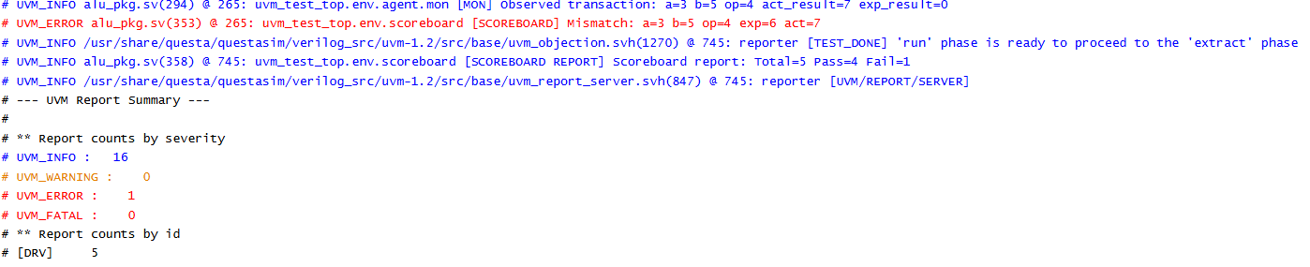
Waveform at the transaction time shows DUT output and expected result, enabling root-cause analysis.

2.1 Install the simulator and verify version
- Install Vivado ML Standard using the official AMD/Xilinx installer (free).
- Open a terminal where Vivado is set up (xvlog/xelab/xsim should work). Windows: use 'Vivado Tcl Shell' or run settings64.bat. Linux/WSL: source settings64.sh.
- Run the version command to verify the install.
xvlog -version
xsim -version
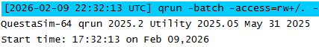
xvlog -version output showing Vivado Simulator v2025.2 — XSIM is installed and on PATH.

2.2 Confirm the UVM library is available
- Create a tiny file tb/uvm_smoke.sv that imports uvm_pkg and prints a message.
- Compile it. If UVM is missing, the compile will fail here (better now than later).
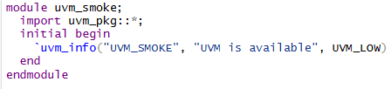
Compile + elaborate commands (example):
xvlog -sv -L uvm tb/uvm_smoke.sv
xelab -L uvm uvm_smoke -snapshot uvm_smoke_sim
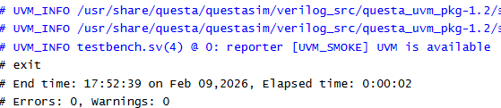
The compile log shows no errors and successfully imports uvm_pkg, confirming that UVM is available in the simulator.
The UVM_INFO message confirms that the simulation ran successfully and executed the UVM code.

2.3 Transcript Log
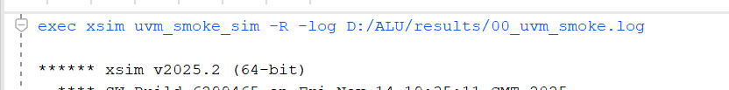
The UVM_INFO tag in the log confirms the run phase executed successfully. The -log switch saved this output to results/ so it can be reviewed after simulation without keeping the console open.

2.4 Waveform Capture

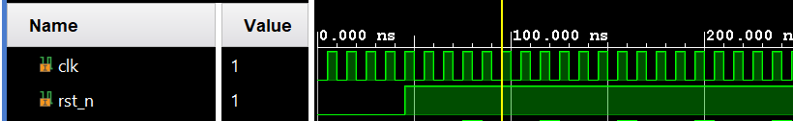

2.5 Common Compile Settings

Used these flags consistently for every compile in this lab:

exec xvlog -sv -L uvm --timescale 1ns/1ps D:/ALU/rtl/alu.sv D:/ALU/tb/alu_if.sv D:/ALU/tb/alu_pkg.sv D:/ALU/top/alu_tb_top.sv

exec xelab -L uvm -debug typical -top alu_tb_top -snapshot alu_tb

Flag reference:

- sv = enables SystemVerilog

-L uvm = links the UVM 1.2 library

- `timescale 1ns/1ps = sets simulation timescale

- debug typical = enables signal visibility in Wave window

3) Create your project workspace (No Git)

3.1 Create the folder structure
Rtl
Tb
Top
Sim
Results
Docs

4) DUT: Tiny ALU RTL + interface contract

4.1 Write the ALU mini-spec
The ALU is a small, fixed-width arithmetic/logic unit with the following properties:
Width: 8-bit operands a and b, 8-bit result result (chosen for fast simulation and easy waveform debug).
Type: Unsigned arithmetic and logical operations.
Opcodes:
- 0 → ADD (result = a + b)
- 1 → SUB (result = a - b)
- 2 → AND (result = a & b)
- 3 → OR (result = a | b)
- 4 → XOR (result = a ^ b)
- 5 → SHL (result=a<<shamt)
- 6 → SHR (result=a>>shamt)
- shamt = b & (WIDTH - 1)
Corner cases to check:
- ADD/SUB overflow wraps around (modulo 2⁸).
- Bitwise ops must preserve all bits.

-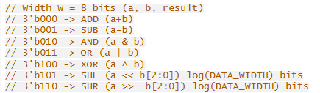
Opcode table defines each ALU operation and its expected behavior, including corner cases such as unsigned comparison and overflow wrap-around. The scoreboard uses this spec as the reference model.

4.2 Timing contract (1-cycle latency)
The ALU follows a valid/ready handshake on both input and output:
Input acceptance rule:
A new transaction is accepted on a rising clock edge when
in_valid == 1 and in_ready == 1.
Latency:
The ALU is combinational (1-cycle latency). The result is valid in the same cycle as the input handshake.

Output contract:
- out_valid is asserted when a valid result is present.
- out_valid remains high until out_ready == 1 and the output handshake completes.
- While out_valid == 1 and out_ready == 0, the result must remain stable.

What is being verified:
- Correct ALU operation for each opcode.
- Correct valid/ready timing on input and output.
- Result stability while out_valid == 1.

Key rules at the clock edge:
- Input accepted: in_valid && in_ready at posedge clk.
- Output consumed: out_valid && out_ready at posedge clk.
- Holding data: out_valid == 1 indicates the DUT is holding a result; this is helpful for verification because the monitor and scoreboard can safely sample the result whenever out_valid == 1.

4.3 Implement rtl/alu.sv (registered handshake + combinational result)
The ALU module exposes the following ports:
- Clock/reset: clk, rst_n (synchronous active-low reset).
- Input handshake: in_valid, in_ready, a, b, op.
- Output handshake: out_valid, out_ready, result.

Internally, the ALU:
- Accepts input when in_valid && in_ready.
- Computes result combinationally based on a, b, and op.
- Asserts out_valid when a result is available.
- Holds result stable while out_valid == 1 and out_ready == 0.
- Deasserts out_valid once out_valid && out_ready completes.

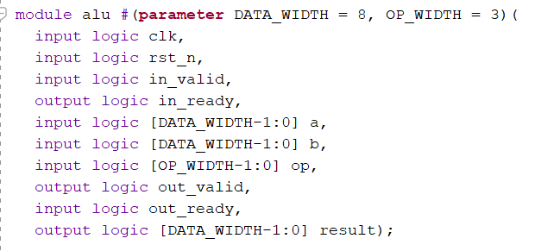
The ALU port list separates handshake signals (in_valid, in_ready, out_valid, out_ready) from data (a, b, result) and opcode (op), making the interface contract explicit and easy to target from the UVM testbench.

4.4 Implement tb/alu_if.sv (interface bundling pins)
A SystemVerilog interface is used to bundle all DUT pins into a single object:
Contains: clk, rst_n, in_valid, in_ready, a, b, op, out_valid, out_ready, result.
Provides modports:
- dut → connected to the DUT instance.
- drv → used by the driver to drive inputs and observe outputs.
- mon → used by the monitor to observe all signals.
Even without clocking blocks, the driver and monitor use @(posedge clk) to align all activity with the synchronous clock.

Handshake rule:
- An input is accepted when in_valid and in_ready are both high on a rising clock edge.
- An output is consumed when out_valid and out_ready are both high on a rising clock edge.
- While out_valid == 1 and out_ready == 0, the DUT must hold result stable.

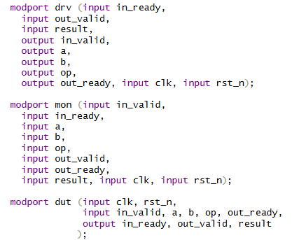
The interface bundles all ALU pins and exposes modports for the DUT, driver, and monitor. This reduces wiring mistakes and provides a single connection point for the UVM environment.

4.5 Create tb/alu_tb_top.sv (DUT + interface + clock/reset)
The top-level testbench:
- Instantiates alu_if and the ALU DUT.
- Connects the DUT ports to the interface dut modport.
- Generates the clock:
initial clk = 0;
always #5 clk = ~clk;
- Drives synchronous reset:
initial begin rst_n = 0;
repeat (5) @(posedge clk);
rst_n = 1;
end
- Calls run_test(); to start UVM.

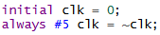
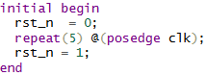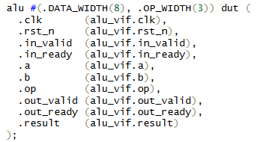
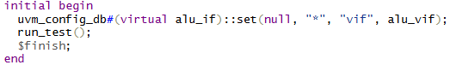
The top-level testbench instantiates the ALU and interface, generates a synchronous clock and reset, and calls run_test() to launch the UVM environment.

4.6 Optional sanity test (non-UVM)
Before building the full UVM environment, a simple non-UVM sanity test can be used:
- Add an initial block in alu_tb_top.sv that:
- Waits for reset deassertion.
- Drives 2–3 handshakes on in_valid, a, b, op.
- Observes out_valid and result in the waveform.
This confirms:
- The ALU computes correct results.
- The valid/ready handshake behaves as expected.
- The timing contract is clear.
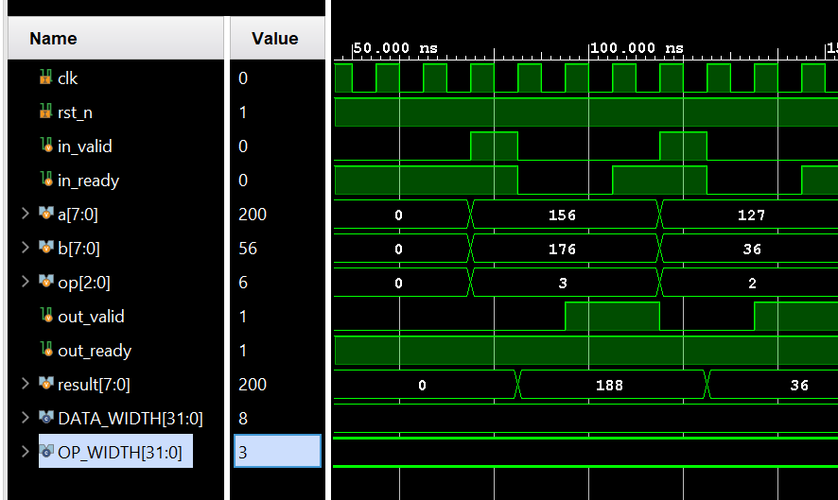
The waveform shows the input handshake (in_valid && in_ready) and the corresponding output handshake (out_valid && out_ready). The result matches the expected ALU operation, confirming the DUT and interface contract before introducing UVM.

5.1 Create tb/alu_pkg.sv (UVM package)
A UVM testbench is easier to maintain when all classes are placed inside a single package.
The package:
- Imports uvm_pkg
- Includes or contains all UVM classes
- Defines the compile order explicitly
Order inside the package:
sequence_item
sequences
driver
monitor
agent
scoreboard
env
tests
This order ensures that each class is defined before any class that depends on it.
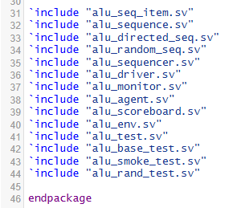
Packages must compile before modules and before any class that depends on them. The compile order shown here ensures that sequence_item is defined before sequences, sequences before driver/monitor, and so on.

5.2 Update alu_tb_top.sv to set the virtual interface
The top module instantiates the interface and passes it into the UVM environment using the configuration database.
Required code in the top module
alu_if alu_vif (.*);
initial begin
uvm_config_db#(virtual alu_if)::set(null, "*", "vif", alu_vif); run_test();
end
Virtual interface:
- UVM components (driver, monitor) are SystemVerilog classes, not modules.
- Classes cannot directly connect to DUT signals.
- A virtual interface provides a handle to the interface instance.
- uvm_config_db is used instead of hierarchical paths to avoid brittle code.
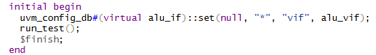
The virtual interface is passed into the UVM environment using uvm_config_db. This allows the driver and monitor to access DUT pins without relying on fragile hierarchical paths.

5.3 Compile-only checkpoint
Before adding sequences or stimulus, compile the following:
- rtl/alu.sv
- tb/alu_if.sv
- tb/alu_pkg.sv
- tb/alu_tb_top.sv
Run the simulation with run_test()

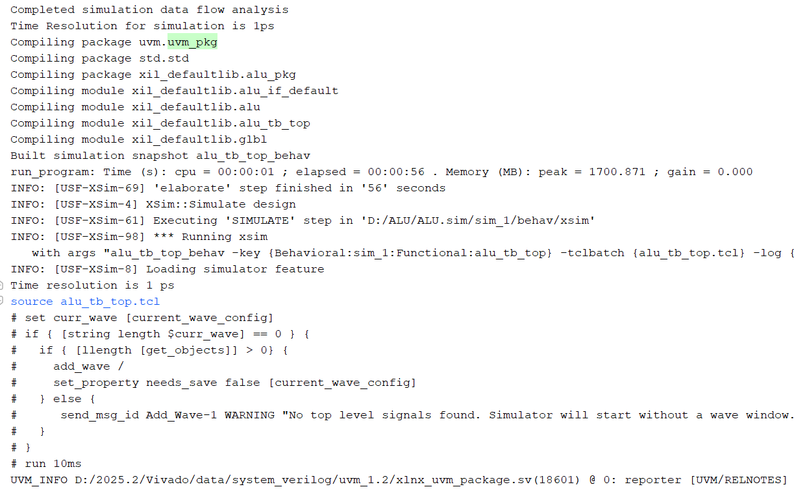
This baseline run shows that the RTL, interface, package, and top compile cleanly and UVM starts without fatal errors. This checkpoint ensures the skeleton testbench is stable before adding components.

6) Transaction: alu_seq_item (sequence_item)
You can generate ALU transactions, randomize them, and print them cleanly.
6.1 Create class alu_seq_item
A transaction object models a single ALU operation.
It contains:
- Stimulus fields
- Result fields (optional)
- Factory registration
Typical fields:
rand bit [7:0] a;
rand bit [7:0] b;
rand bit [2:0] op;
bit [7:0] exp_result;
bit [7:0] act_result;
Transaction object:
- Keeps stimulus abstract and reusable
- Allows randomization
- Allows logging and debugging
- Decouples test intent from pin-level details
Field meanings:
- a, b: 8-bit operands
- op: ALU opcode (0–6)
- exp_result: reference model output
- act_result: DUT output captured by monitor

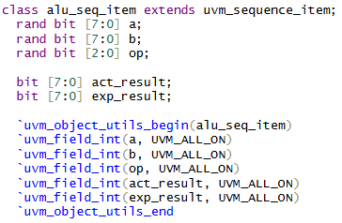
Stimulus is modeled as a transaction object so tests can generate operations abstractly. Fields a, b, and op represent the ALU inputs; exp_result and act_result support scoreboard checking.

6.2 Add constraints
Constraints ensure randomization produces legal, meaningful transactions.
Constraint:
- Prevents illegal opcodes
- Keeps random tests meaningful
- Avoids scoreboard mismatches caused by undefined behavior

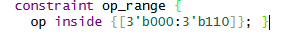
The opcode is constrained to the legal range 0–6. This prevents illegal operations and ensures that randomized transactions always match the ALU specification.

6.3 Add convert2string()
Readable logs are essential for debugging.
function string convert2string();
return $sformatf("a=%0d b=%0d op=%0d act_result=%0d", a, b, op, act_result);
endfunction
This allows:
- Driver logs
- Monitor logs
- Scoreboard logs
to print transactions in a consistent format.

6.4 Randomization smoke test
Before connecting to the DUT, generate a few random transactions:
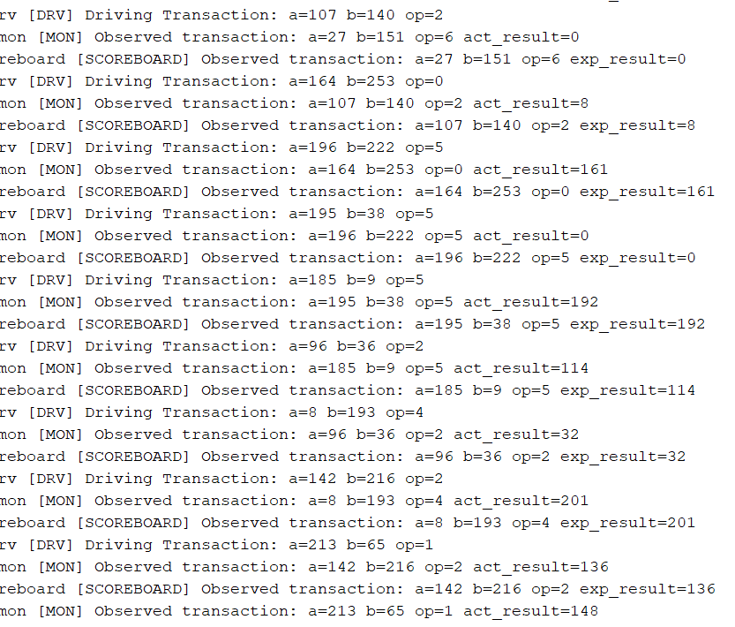
The printed transactions show that a, b, and op randomize correctly and op stays within the legal range. This confirms that the sequence_item and constraints are working.

7.1 Directed Sequence (Corner Cases)
A directed sequence generates a fixed, known set of transactions that target specific corner cases.
This is essential for early smoke testing and for catching deterministic bugs.
Key characteristics of a directed sequence
- Produces predefined items
- Covers edge cases deliberately
- Useful for debugging and validating the DUT contract
Typical directed cases for an ALU
- (0, 0) → tests zero behavior
- (max, 1) → tests overflow wrap-around
- (max, max) → tests subtraction and comparison edge cases
- Shifts by 0 and by W-1 → tests shift boundaries
- XOR patterns like 0xAA ^ 0x55 → tests alternating bits
The directed sequence includes zero, max, overflow, shift-boundary, and XOR-pattern cases. Each case targets a specific bug class such as overflow wrap-around, shift edge behavior, or bit-pattern correctness.

Directed vs Randomized
- Directed sequence: fixed, known values → good for smoke tests
- Random sequence: unpredictable values → good for coverage and bug hunting
Test length knob
A variable such as ntxn controls how many items the random sequence generates.
This is useful because:
- Short tests for debugging
- Long tests for coverage
- Reproducible tests using seed + ntxn
Reproducing a failure
A failing random test is reproduced by rerunning with:
exec xsim alu_tb -R -testplusarg UVM_TESTNAME=alu_rand_test -testplusarg ntxn=200 -sv_seed 999 -log D:/ALU/results/rand_run.log

7.2 Random Sequence (Length Controlled by ntxn)
A random sequence generates a stream of randomized transactions.
Structure
- Loop from i = 0 to ntxn -1
- Create a new alu_seq_item
- Randomize it
- start_item() / finish_item()
- Optional: print every N items
Why this matters
- Exercises many operand combinations
- Finds unexpected corner cases
- Works with functional coverage
- Reproducible with seed + ntxn

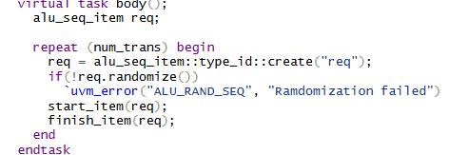
The random sequence generates ntxn randomized transactions. The ntxn knob controls test length, enabling both short smoke tests and long coverage runs.

7.3 How Sequences Are Selected
UVM tests choose which sequence to run:
- alu_smoke_test → runs the directed sequence
- alu_rand_test → runs the random sequence
Selection is done at runtime:
exec xsim alu_tb -R -testplusarg UVM_TESTNAME=alu_smoke_test -testplusarg UVM_VERBOSITY=UVM_MEDIUM -sv_seed 12345 -log D:/ALU/results/smoke_run.log

exec xsim alu_tb -R -testplusarg UVM_TESTNAME=alu_rand_test -testplusarg UVM_VERBOSITY=UVM_LOW -testplusarg ntxn=200 -sv_seed 999 -log D:/ALU/results/rand_run.log
Stimulus is generated by selecting either the directed or random sequence using UVM_TESTNAME. This allows switching tests without recompiling.

8) Driver (BFM Behavior)
The driver consumes sequence_items and drives the DUT interface cycle-by-cycle, respecting valid/ready timing.
8.1 Driver Class + Virtual Interface
The driver extends uvm_driver#(alu_seq_item) and retrieves the virtual interface in build_phase.
if (!uvm_config_db#(virtual alu_if)::get(this, "", "vif", vif))
`uvm_fatal("NOVIF", "Virtual interface not set")
Why this matters
- The driver must access DUT pins
- The virtual interface is the only safe way
- Missing vif → null handle → UVM_FATAL

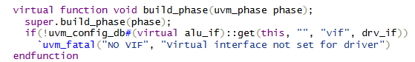
The driver retrieves the virtual interface from uvm_config_db. If the vif is missing, the driver issues a UVM_FATAL to prevent null-handle access.

8.2 Reset / Idle Behavior
During reset:
- in_valid = 0
- a = b = op = 0
- Driver waits for reset deassertion
- Driver waits 1–2 cycles before sending stimulus
This ensures clean startup behavior.

8.3 Driving One Transaction (Cycle-by-Cycle)
Driver handshake behavior
- Wait for in_ready == 1
- Drive a, b, op
- Assert in_valid
- On the next posedge where in_valid && in_ready → handshake occurs
- Deassert in_valid
- Wait for DUT to produce output
Why the driver should NOT compute expected results
- Scoreboard owns checking
- Driver only drives pins
- Separation of concerns avoids double-counting bugs

8.4 Backpressure Support
If in_ready == 0:
- Driver keeps in_valid = 1
- Driver holds a, b, op stable
- Driver waits until ready returns high
This models real hardware behavior.

8.5 Driver Logging
The driver logs each transaction using:
`uvm_info("DRV", t.convert2string(), UVM_MEDIUM)
This makes debugging easier and keeps logs readable.

9) Monitor (Sampling What Actually Happened)
The monitor observes DUT handshakes and outputs, reconstructs completed transactions, and publishes them to the scoreboard.
9.1 What the Monitor Publishes
The monitor is responsible for observing DUT behavior, not generating stimulus.
It reconstructs each completed ALU transaction by sampling:
- a
- b
- op
- result (actual DUT output)
- Simulation time or cycle count
How observation is captured
- The monitor samples signals on posedge clk.
- When in_valid && in_ready is high at a clock edge, the monitor records the input operands and opcode.
- When out_valid && out_ready is high at a clock edge, the monitor records the output result.
- The monitor pairs the input handshake with the corresponding output handshake to form a complete transaction.
What the monitor observes that the driver must NOT assume
- Whether the DUT actually accepted the input
- Whether the DUT produced a valid output
- Whether the DUT held the result stable under backpressure
- Whether the DUT violated the protocol (e.g., changed result while out_valid==1)
Signals sampled and when
- Sampled on posedge clk
- Signals: in_valid, in_ready, a, b, op, out_valid, out_ready, result
Result instability
If out_valid == 1 and out_ready == 0, the result must remain stable.
If it changes, the monitor reports a protocol violation.
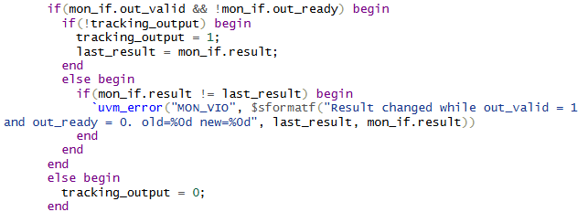
The monitor samples a, b, op, and result on posedge clk. It detects protocol violations such as result instability while out_valid==1.

9.2 Analysis Port → Scoreboard
The monitor uses a UVM analysis port to publish completed transactions:
uvm_analysis_port#(alu_seq_item) ap;
When the output handshake completes:
ap.write(tr);
A reference model is a pure function that computes the expected result from (a, b, op):
- No timing
- No delays
- No access to DUT internals
- No side effects
This ensures the scoreboard checks correctness independently of DUT timing.
When a mismatch occurs, the log must print:
- Expected result
- Actual result
- The full transaction (a, b, op, time)
Fail-fast vs Collect-errors
- Fail-fast: stop simulation on first mismatch
- Collect-errors: continue simulation and count all mismatches
Most educational UVM projects use collect-errors so students can see all failing cases.

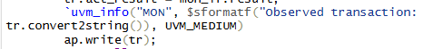
The monitor publishes completed transactions through an analysis port. The scoreboard uses a pure reference model to compute expected results and compare them against DUT outputs.

9.3 Basic Protocol Checks
The monitor enforces the DUT’s timing contract:
- If out_valid == 1 and out_ready == 0, the result must remain stable.
- If reset is asserted, the monitor clears its internal queues and ignores activity.
- If in_valid toggles without ready, the monitor can warn about suspicious behavior.
A protocol violation was injected by forcing the DUT to change result while out_valid==1. The monitor reports the violation with a clear message.

9.4 Monitor Logging
To keep logs readable:
- Print every Nth transaction (e.g., every 10th)
- Use UVM_MEDIUM for normal runs
- Use UVM_HIGH for debugging
What the monitor observes that the driver must not assume
- Whether the DUT accepted the input
- Whether the DUT produced the correct output
- Whether the DUT respected the valid/ready protocol
The monitor logs observed transactions at controlled verbosity. It samples signals on posedge clk and reconstructs each completed ALU operation.

10) Scoreboard + Reference Model
Every observed transaction is checked against a pure reference model.
10.1 Reference Model Function
A reference model is a pure SystemVerilog function:
- No timing
- No delays
- No access to DUT signals
- Deterministic and side-effect-free
This ensures correctness checking is independent of DUT implementation.

10.2 Scoreboard Comparison
When the monitor publishes a transaction:
- Compute expected result using alu_ref()
- Compare expected vs actual
- Increment pass/fail counters
- Log mismatches with full detail
What correctness checking means
- For each opcode, the scoreboard applies the ALU spec
- A comparison is counted when the output handshake completes
- A mismatch is reported immediately with:
- Expected
- Actual
- Operands/opcode
Fail-fast vs Collect-errors
- Fail-fast: stop on first mismatch
- Collect-errors: count all mismatches
Educational UVM projects typically use collect-errors.
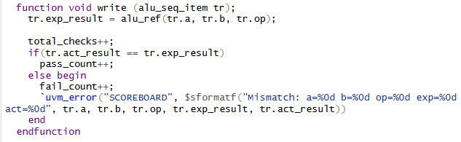
The scoreboard computes expected results using a pure reference model and compares them against DUT outputs. Mismatches print expected, actual, and the full transaction.

10.3 End-of-Test Summary
In report_phase, the scoreboard prints:
- Total comparisons
- Pass count
- Fail count
If failures exist, the scoreboard prints the first few failing transactions.

The scoreboard summary reports total comparisons and failures. A comparison is counted when an output handshake completes. This run shows failures = 0, confirming DUT correctness.

10.4 Debug Exercise
To demonstrate the debug workflow:
- Break one opcode in the DUT (e.g., XOR → OR).
- Run the directed test.
- Observe mismatch in scoreboard.
- Locate mismatch in waveform.
- Fix the DUT.
- Re-run and confirm PASS.

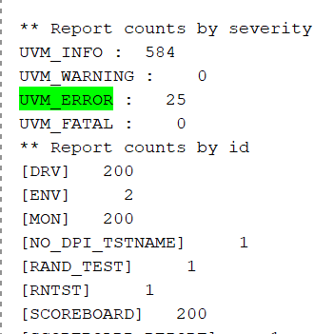

The injected bug caused a mismatch: expected XOR result vs actual XOR result. After fixing the DUT, the scoreboard summary shows failures = 0. This demonstrates the full debug workflow.

11) Agent + Environment Wiring
The UVM environment is structured like real DV code:
- The agent bundles sequencer + driver + monitor
- The environment connects the agent to the scoreboard
- All wiring is centralized and clean
11.1 ALU Agent (Active Agent)
The agent encapsulates the three core UVM components:
- Sequencer - provides transactions
- Driver - drives DUT pins
- Monitor - observes DUT behavior
This grouping makes the agent a reusable verification unit that can be plugged into any environment.
Why UVM uses an agent
- Keeps sequencer/driver/monitor together
- Makes the testbench modular and reusable
- Allows switching between active and passive modes
- Mirrors industry-standard DV architecture
Active vs Passive Agent
Active agent:
- Has a sequencer and driver
- Generates stimulus
- Used when verifying a DUT interface
Passive agent:
- Only has a monitor
- Used when observing traffic without driving it

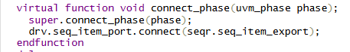
The ALU agent bundles sequencer, driver, and monitor into a reusable unit. The driver’s seq_item_port is connected to the sequencer’s seq_item_export, making the agent active.

11.2 ALU Environment (env) + Analysis Path
The environment instantiates:
- alu_agent
- alu_scoreboard
And connects the monitor’s analysis port to the scoreboard’s analysis implementation.
Why the environment owns all connections
- Centralizes wiring
- Keeps agent reusable
- Keeps scoreboard reusable
- Matches industry best practices

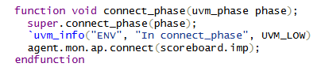
The environment instantiates the agent and scoreboard and connects the monitor’s analysis port to the scoreboard. All wiring is centralized in the environment for clean architecture.

11.3 Compile Checkpoint (Agent + Env)
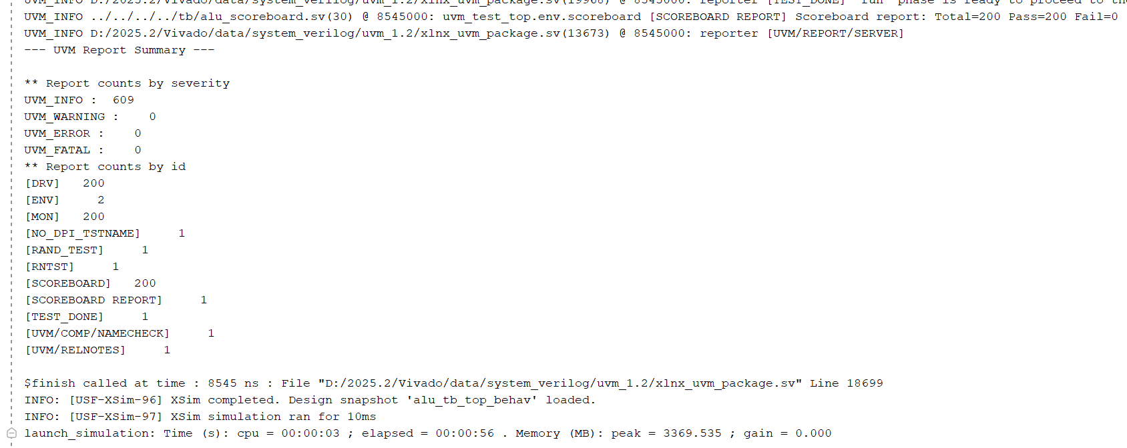
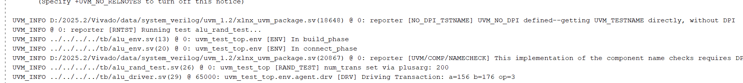
This checkpoint confirms that the agent and environment build correctly and UVM starts without null-pointer errors. This is the baseline before adding sequences.

12) Tests + Reproducibility (Plusargs, Seeds, Scripts)
Run smoke and random tests using only command-line arguments.
12.1 Base Test (alu_base_test)
The base test:
- Builds the environment
- Reads plusargs (-testplusarg ntxn =200)
- Sets default knobs
- Starts a sequence in run_phase

phase.raise_objection(this);
seq.start(env.agent.sequencer);
phase.drop_objection(this);

This ensures the test runs until the sequence completes.

12.2 Two Tests: Smoke + Random
1. alu_smoke_test
- Runs the directed sequence
- Deterministic
- Good for early debugging
2. alu_rand_test
- Runs the random sequence
- Uses ntxn
- from plusarg
- Good for coverage and stress testing

exec xsim alu_tb -R -testplusarg UVM_TESTNAME=alu_smoke_test -testplusarg UVM_VERBOSITY=UVM_MEDIUM -sv_seed 12345 -log D:/ALU/results/smoke_run.log

exec xsim alu_tb -R -testplusarg UVM_TESTNAME=alu_rand_test -testplusarg ntxn=200 -sv_seed 999 -log D:/ALU/results/rand_run.log

The smoke test runs the directed sequence; the random test runs the randomized sequence with ntxn from plusargs. Both tests are selected using -testplusarg UVM_TESTNAME in XSIM.

12.3 Plusargs + Seed Control
Test selection
In Vivado XSIM plusargs use -testplusarg flag and seed uses -sv_seed:
- testplusarg UVM_TESTNAME=alu_smoke_test
- testplusarg UVM_VERBOSITY=UVM_MEDIUM
- sv_seed 12345
- testplusarg ntxn=200

Verbosity control
UVM_VERBOSITY=UVM_MEDIUM
Random seed
sv_seed =12345
Random test length
- testplusarg ntxn =200

exec xsim alu_tb -R -testplusarg UVM_TESTNAME=alu_smoke_test -testplusarg UVM_VERBOSITY=UVM_MEDIUM -sv_seed 12345 -testplusarg ntxn=200 -log D:/ALU/results/run.log

Why reproducibility matters
- Allows debugging a failing random test
- Ensures identical stimulus across runs
- Enables regression testing

12.4 Saving Artifacts Per Run
In Vivado XSIM, artifacts are saved automatically per run using the -log and -wdb flags. Create one subfolder per run:
results/run_20250219_seed12345_smoketest/
run.log
run.wcfg

